Oops

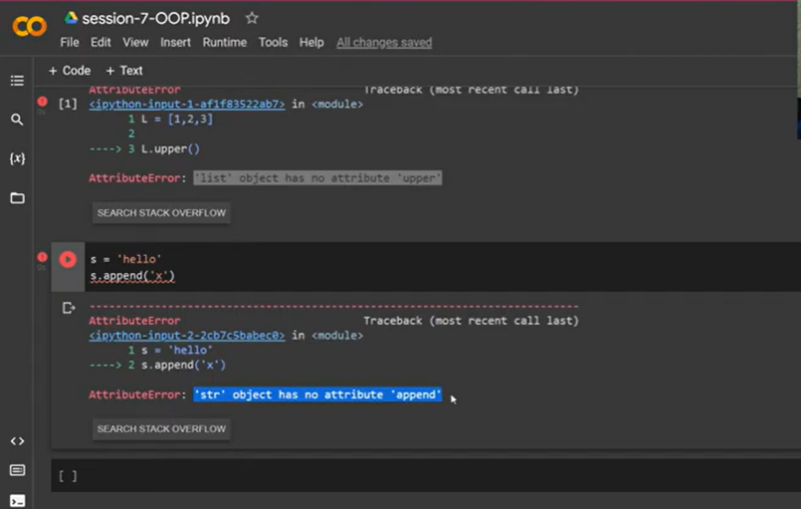

Str , list – called object

In python everything is called object

Oop?

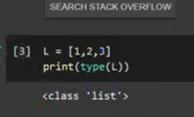

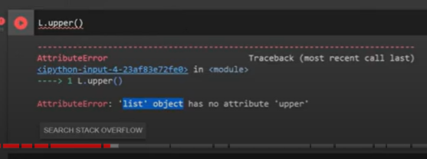

Which one called list and object

Whatever data types – class or build in classes

When we create any variable In name of variables – object

List- class

L=[1,2,3]

L= object

Class – blue print

Object: behave like class, it follows rules mentioned in class

Car: class

Maruti sujiki : object

Python : data types: class

Variables of datatypes- objects

We can see all functions and method available for objects

L.append()

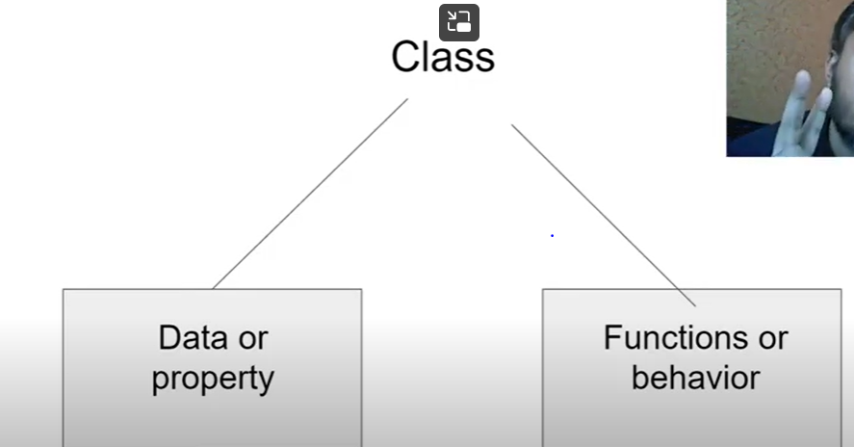

Data or property or attribute

Function or behaviour or method

Car

Colour body type ,speed – attribute

Cal avg speed – method

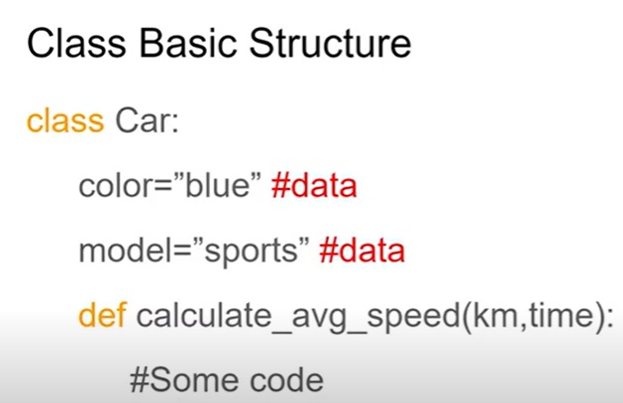

Object: instance of class

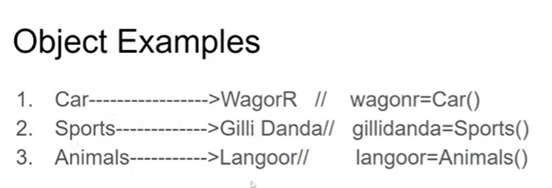

Syntax to create object

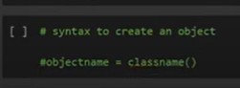



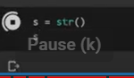

Class name:

---Should be pascalcase

UmaMahi

MyIndia

Class should have data and methods

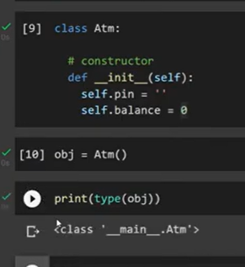

Object can access things that are present in class

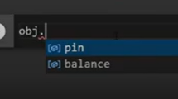

This is user defined class

There are built in classes like string,list,tuple

What are the functions of Atm

We can create pin

Change pin

Check balance

Withdraw balance

Fist write the function to see menu()

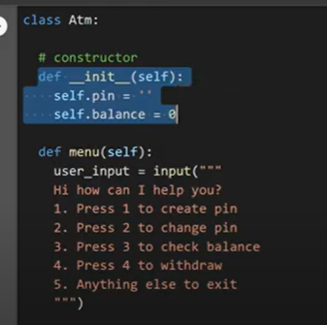

Constructor is special function:

It has special super power

It doesn’t require to call a function to execute

No need to call constructor function

As soon as we create object the constructor function gets executed

--

So we will call menu function within constructor

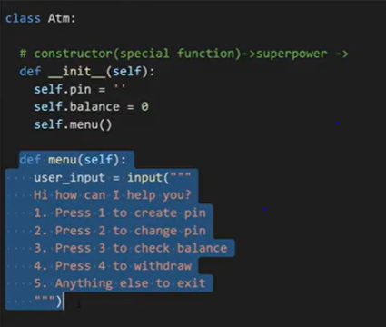

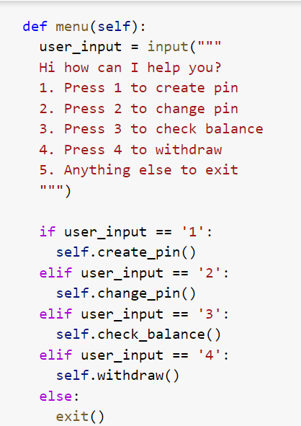

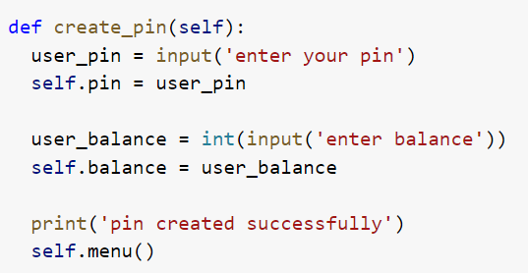

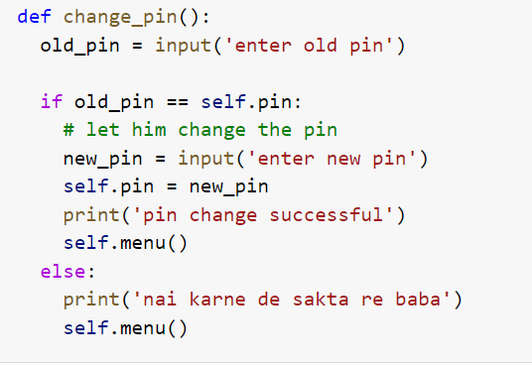

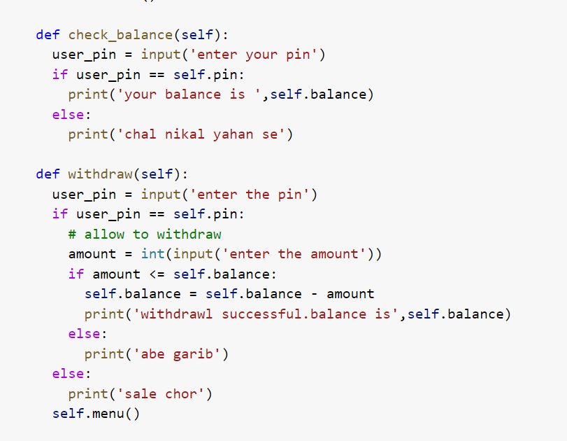

Obj =Atm()

Methods vs function

When we write function within a class : method

Function outside of class – function

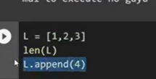

Len- function

Append- method--- append implemented list class

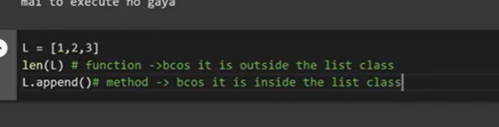

Class diagram :

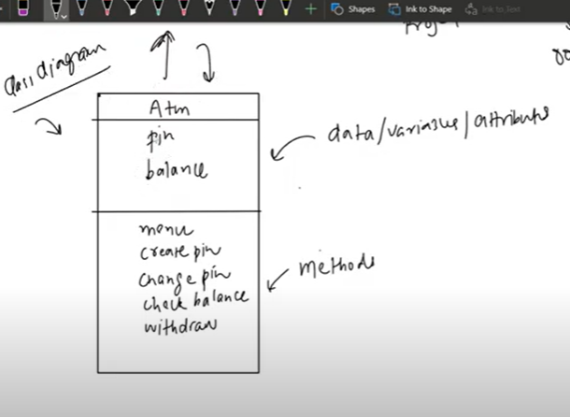

Magic methods:

+: public , visible outside the class

-private – will not be visible outside the class

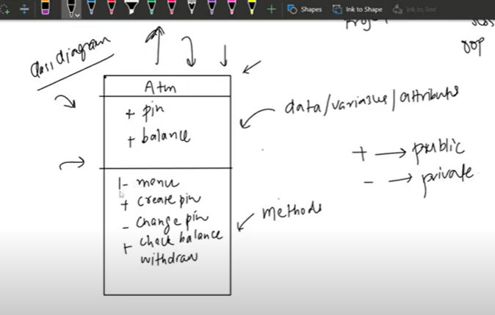

Magic methods;

or

Dunder methods :

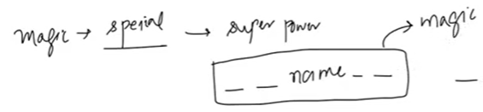

Magic method has super power

Ex : constructor – doesnot require to call

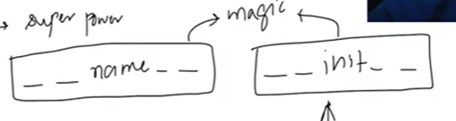

1. Magic method: Constructor

It is method but a special method

It has special power

It gets executed automatically when it calls

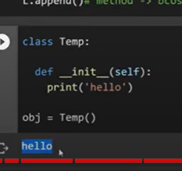

What is the benefit of constructor?

The constructor – the control will not be with user

Like when we visit atm display menu is automatically execute

Used to write configuration related code( it control with developer)

Self: default parameter in every method

For representing variables : self. Colour

To call a method: obj.method(self)

Or self.method()

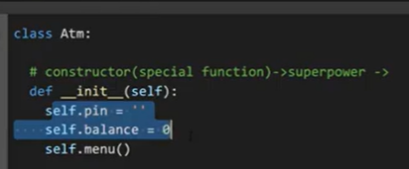

Golden rule of OOB:

who can access the attribute and methods of a class?

Only Object of that class

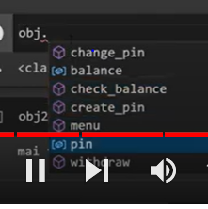

Python everything is obj

Even self is object

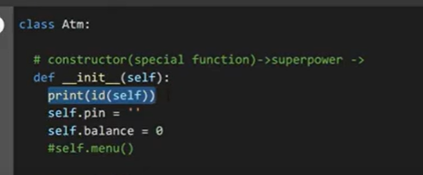

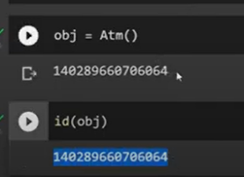

The address of self and obj is same

Means self is object itself.

Why to we metion self?

Self.method()

Within one function when we talk about other function there is only one way that is self.method()

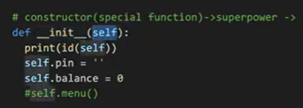

Self.menu()

Other function in init method.

When we don’t mention self in a method?

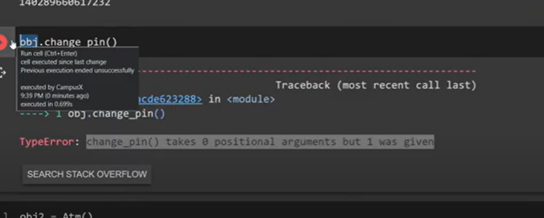

Change_pin() metod was not given as self argument in it, so when we call that method with object the error comes

It says 1 parameter was given that is object itself

We cant call method in another method without reference of obj(sel)

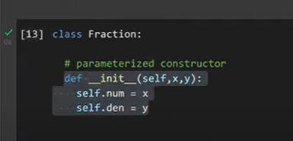

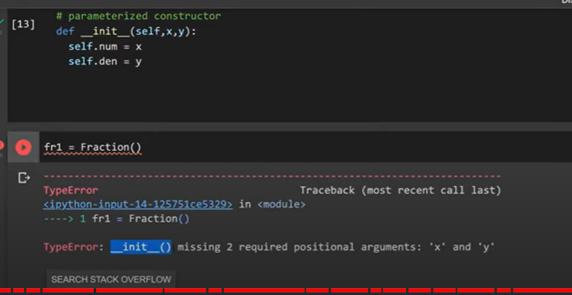

In order to create obj we req 2 arguments as constructor has 2 parameters

-__name__ any name with before double underscore and after double underscore

__str__:

When we print obj..

Whenever we print object will return the return function of str

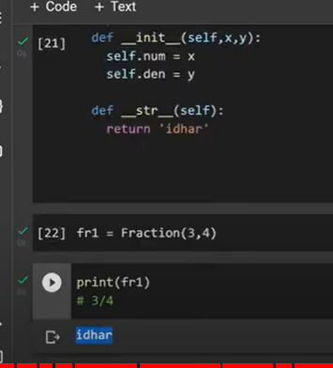

Here when we print obj – print(fri)- it return the idhar

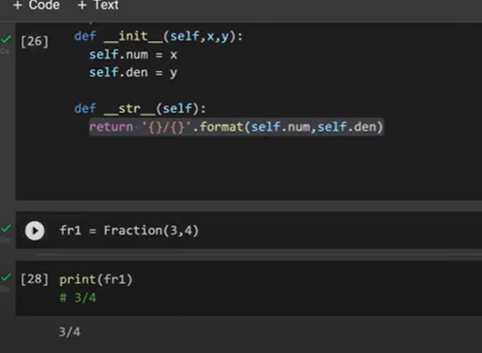

-----------------------------------

Now create data type called fraction by using class:

When we do some actions on data fraction data should be return

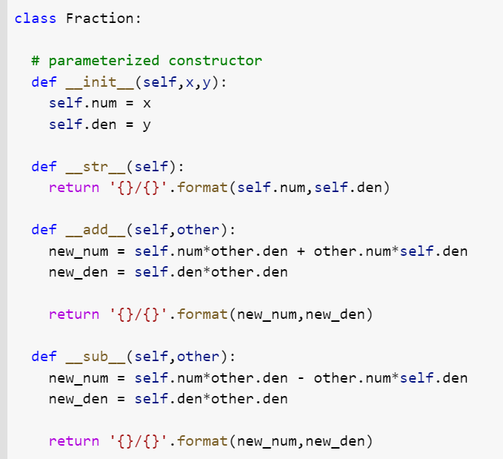

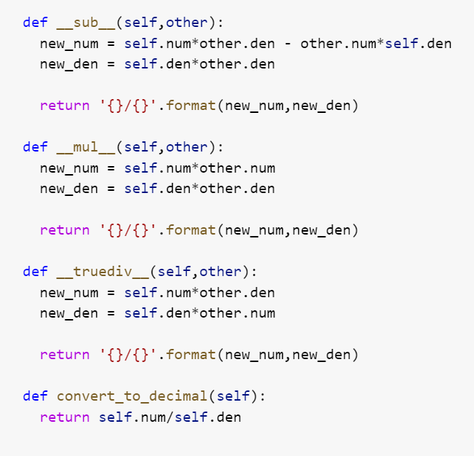

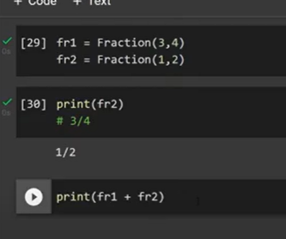

When we try to add fraction 1 and fraction 2

It wont get added

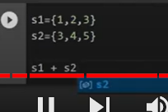

Unsupported

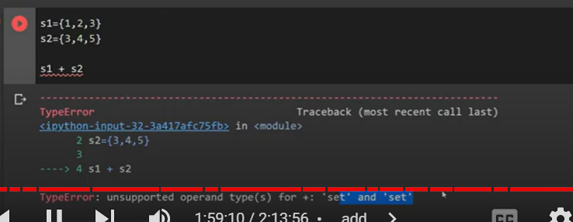

There is no logic written to add between 2 set

To deal with another magic method

__add__

It has 2 arg : self , other

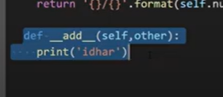

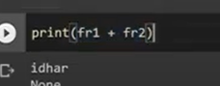

Fr1 in self , fr2 – other

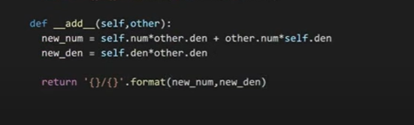



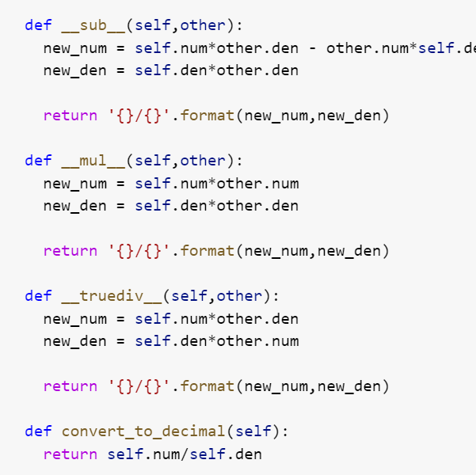

[session-7-OOP.ipynb - Colaboratory (google.com)](https://colab.research.google.com/drive/1bzZ5WiHXcnsxZThKEefsM8HOuBPwCany?usp=sharing#scrollTo=Q19W8x5Y-KHv)

--------------------------------------------------------------------------------------------------------------------------------------------------

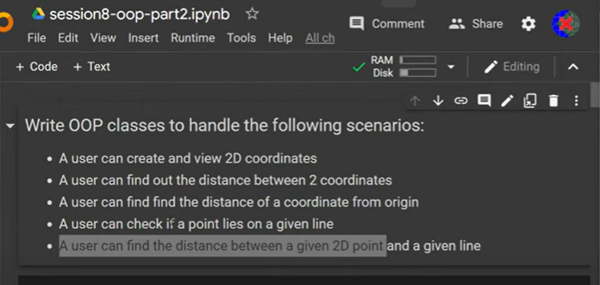

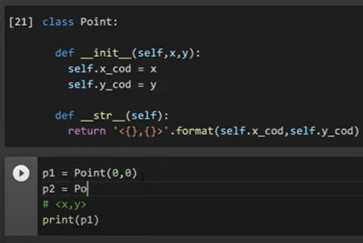

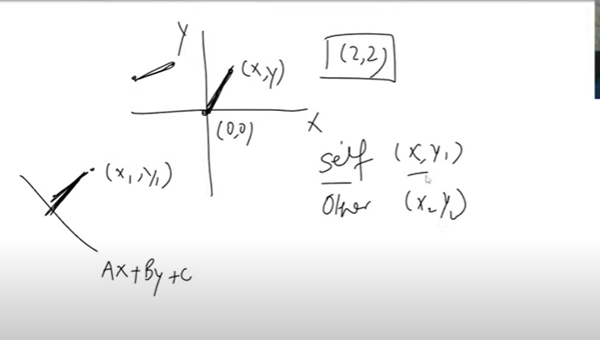

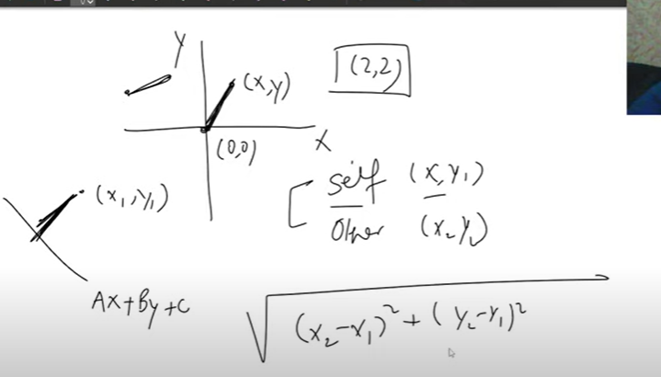

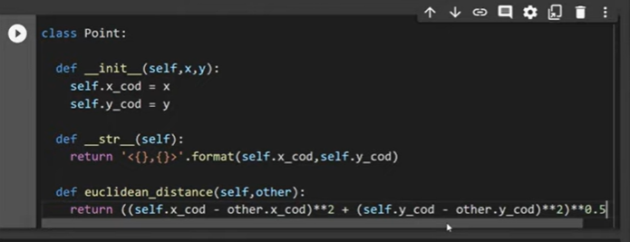

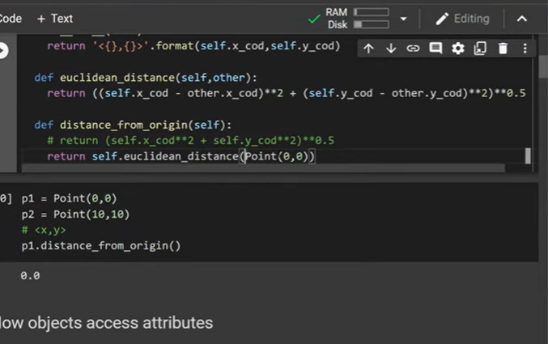

Line

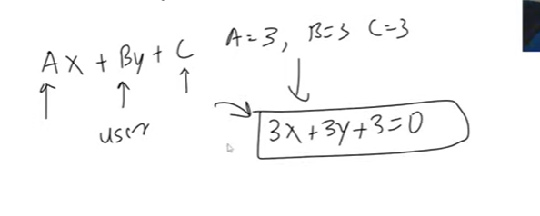

Now function to see if point on line

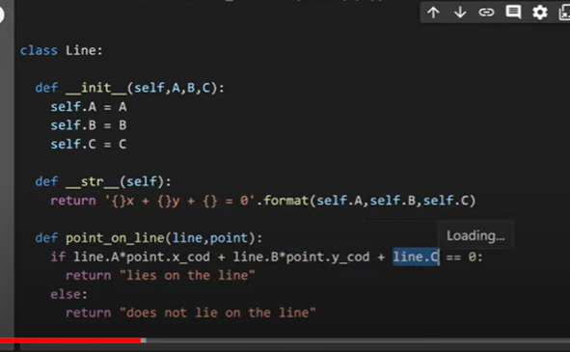

<https://colab.research.google.com/drive/1F3Y_zoZH0BDdvcFwrHS46YXj8CCNDRq>

shortest distance

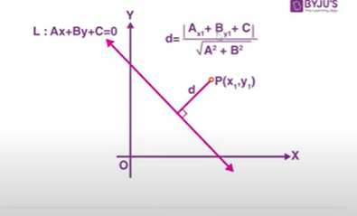

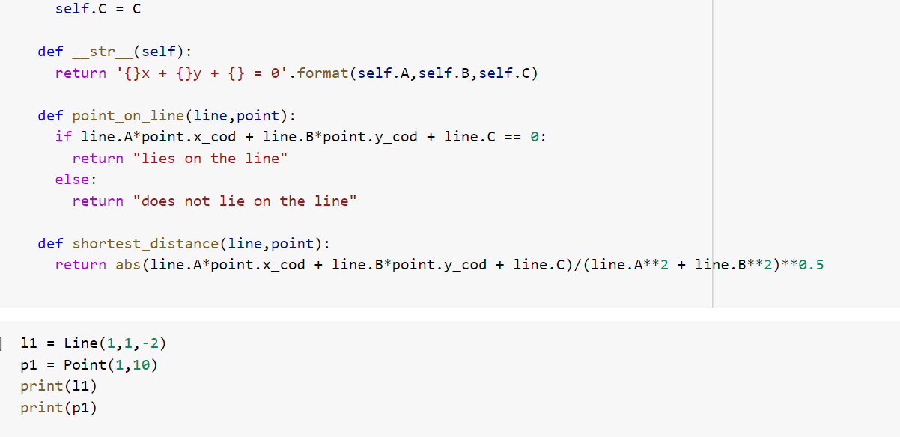

How object access attributes

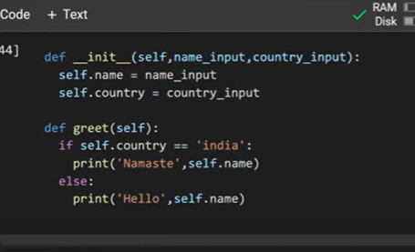

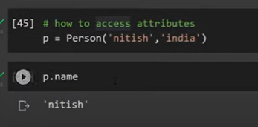

We can access both methods and attributes

p.name

p.greet()

p.gender

error as class has no error

but we can create attributes outside of class

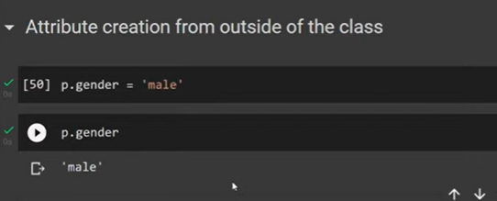

How object access attributes?

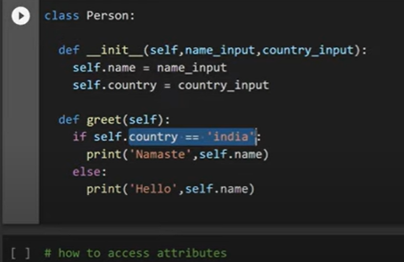

Object

P=person(“uma”,”india”

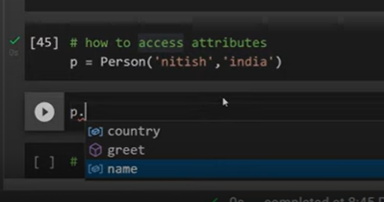

When we create object, object has power to access both attributes and methods

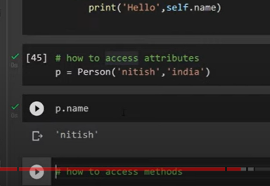

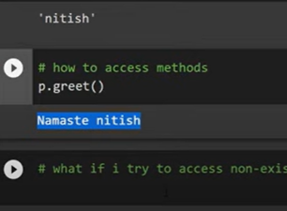

What if we try to access attribute which is not in class?

Error wll come

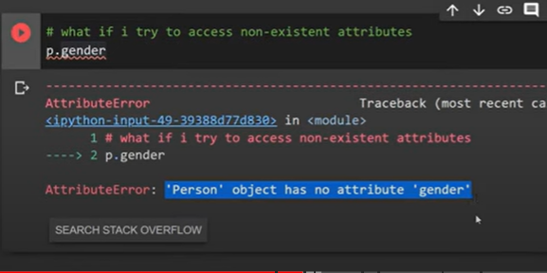

If we do like below

Attributes created outside of class:

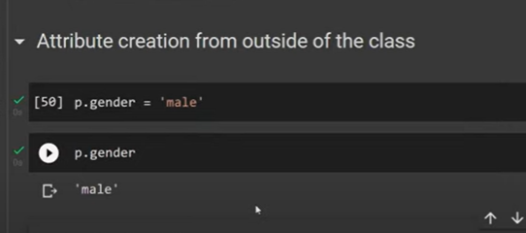

Using object we can create attributes outside of class

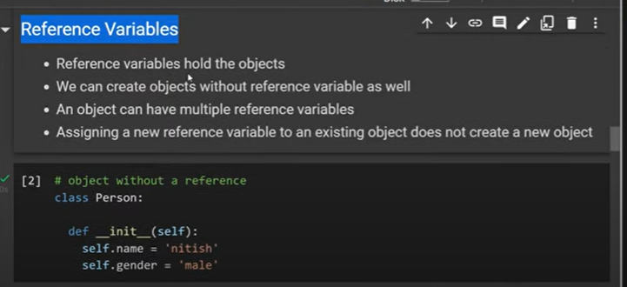

Reference Variable:

When we wanted to create a object we will store that in a variable

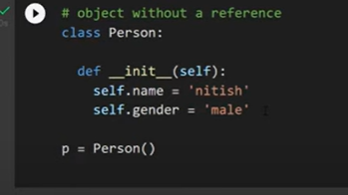

Here “p” is variable where we store object of persion

:can we create object without a variable?

Person()

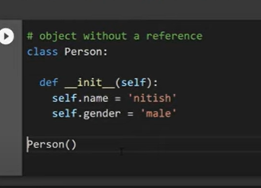

Will it create object?

Yes

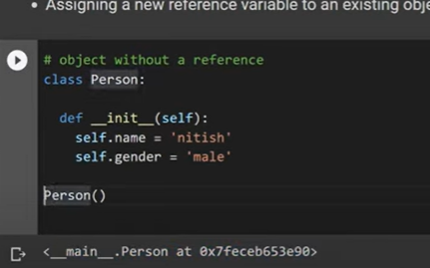

Actually when we call person()- it creates object

P is not object

P contain address of the object that has been created

It hold the address

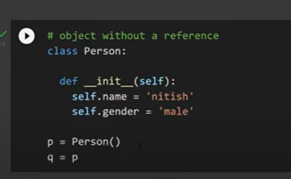

If p=q means both are pointing to same object

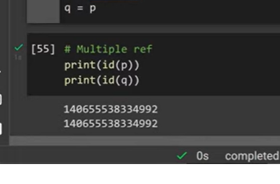

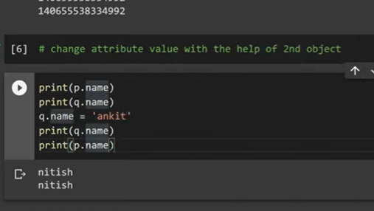

When we change q name

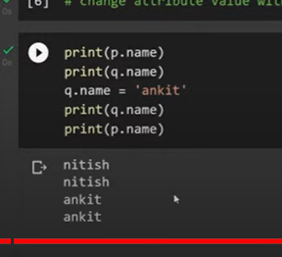

P also gets changed

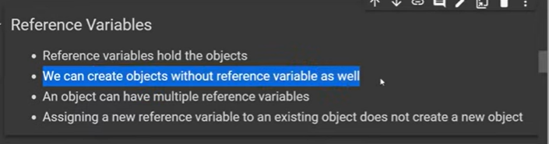

Pass by reference:

When we create a function outside of a class

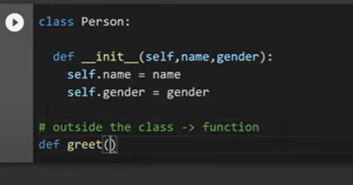

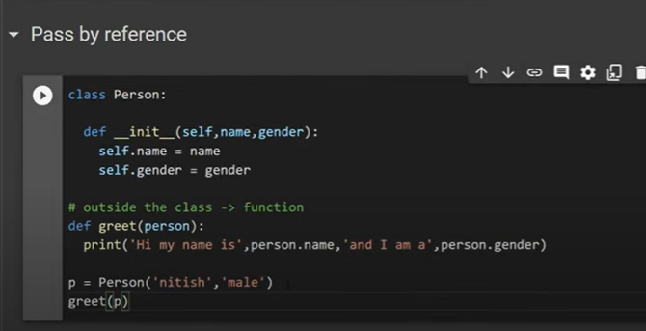

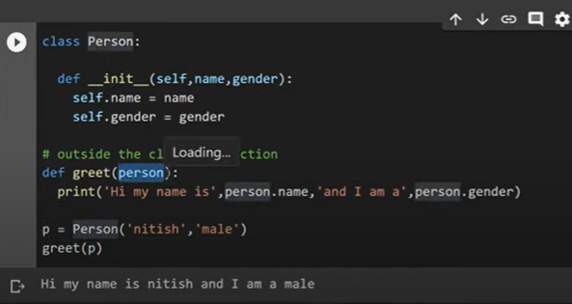

Here in function we have passed object as an reference

Now in function we created another object and returned that object

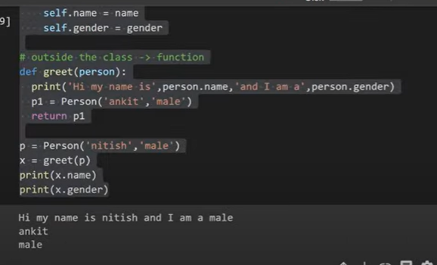

Now see id of p

Id(person)

Is there any difference?

Same

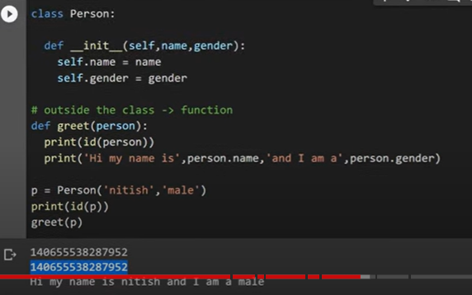

Here we didn’t send obj, but we passed the object address or reference

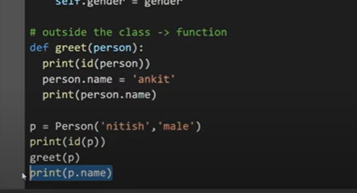

What happen

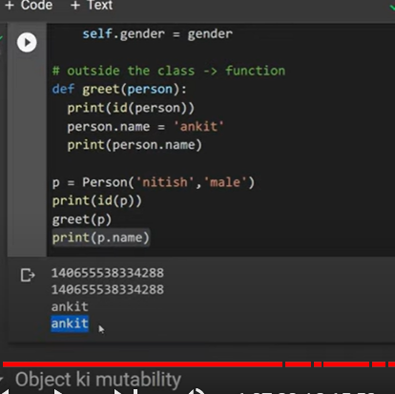

Both ankit only

Object Mutability:

Objects are mutable, but address will not change ,

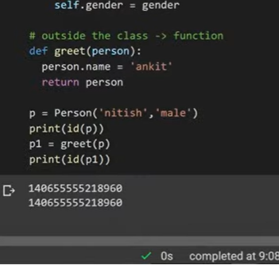

Instance variable?

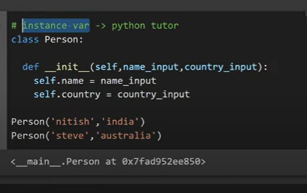

In construction Name and countey called instance variable

They diff for diff objects

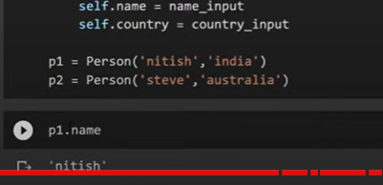

Name is one variable but it has 2 diff values

It can store multiple values

The value will be based on object

Instance variable is special variable the value will be diff fordiff objects

----------------------------------------------------------------------------------------------------------------------------------

Encapsulation

If I am a senior coder

There is junior under you

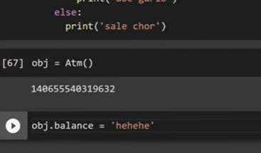

If he try to change obj.attribute – it will change if we don’t do encapsulated

Code got crashed

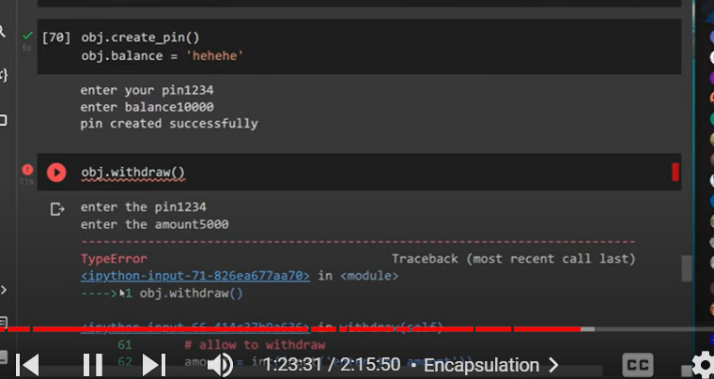

Junior programmer changed code to hehehe

Balance is not number any more so error

Becoz junior programmer got access to attribute

What to do now?

Concept Private variables

We need to change all variable into private

__”double underscore” before attribute

Wherever we are using this attribute should be changed to double underscore

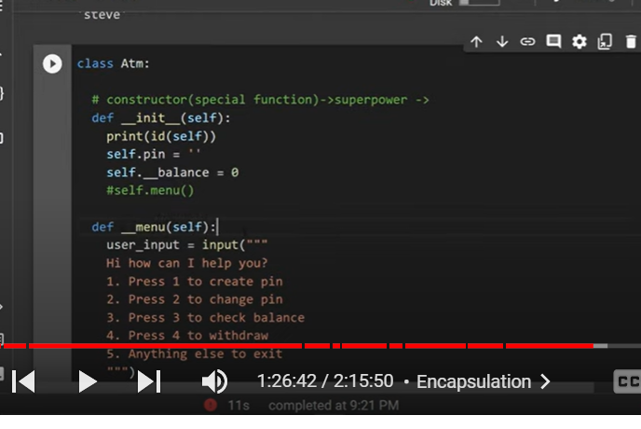

Even methods also we can change to double underscore

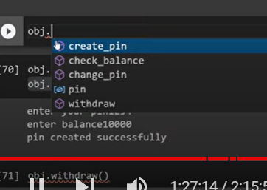

Now he cant access menu and balance as they are made as private attributes and methods

What if we change pvt variable

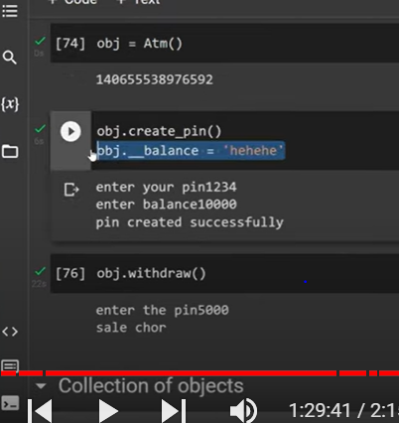

We will not get error

Why?

When we made variable private

In memory the name will become _classname__balance

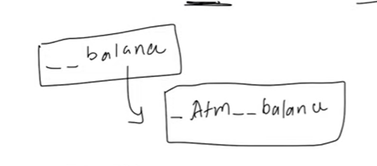

When he write like this

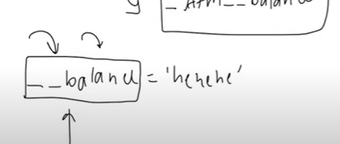

It creates a new variable __balance

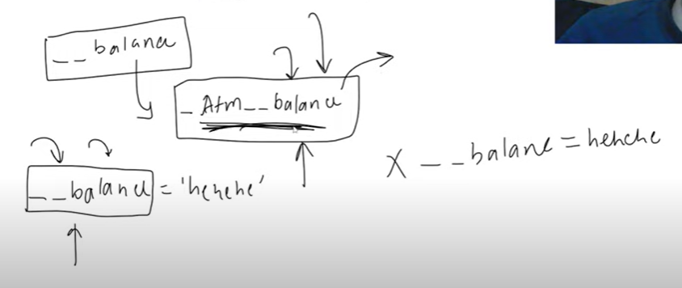

But code will be based on _Atm__balance

So it wont crash

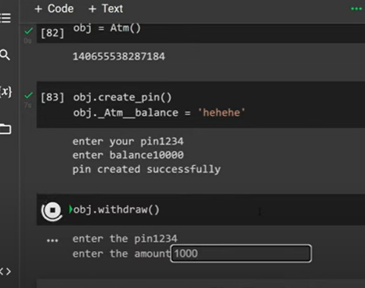

Now if he try this

Withdraw method will not work

Even after made it private

Junior could able to change code

Because in pythod nothis is truly private – python is programming language for adults

Junior programmer wrong- he should know that he shouldn’t change it

Each variables in class must be made as private

Private variable can accessed within class

Means – methods can access within class-

Getter, setter

2 methods

Getter

Setter

Getter : to get pvt variable outside

Setter : can change pvt variable outside of class

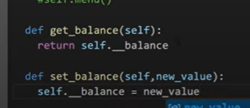

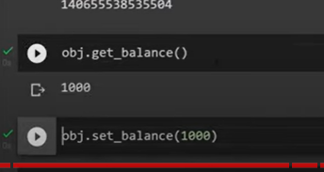

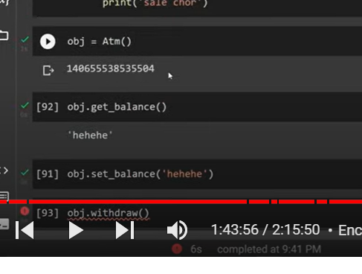

Code crash

So we need to change code in set

